COMPANY PROFILE

ATC Logistical Solutions Pvt. Limited
Mission Statement

Offer the best in class integrated & end to end logistical solutions across industry verticals with innovative approach that will help valued clients to manage the supply chain processes and distribution seamlessly.

ATC is one of the oldest (established in 1939) and reputed surface distribution & logistics company of our country. Principally, it was a secondary transportation & distribution company with a national spread and very strong presence in Northern & Western part of India with special focus on Kolkata too. Operationally, it is a well footed company with well experienced manpower available within the organization. Brand image is well established and strongly positioned.

The late thirties was a time of political turmoil in India. It was also an era when the country was just awakening to its identity and the possibilities that lay before it. Transportation facilities were critical to the evolution of the national economy. Realising this, Late Lala Sain Dass (fondly known as Bijli Pehalwan ji) stepped in resolutely, determined to make a contribution. The beginning was modest and the company served the frontier regions of Lahore, Rawalpindi and Peshawar. Soon trouble lurked around the corner. Came the partition of India and company got relocated on the Indian side of the subcontinent.ATC emerged stronger, better and much more determined after the initial setbacks. It became the first transportation company in Independent India to be awarded a National Permit.

Fast changing technology and economical changes which in taking place throughout world has completely changed logistical/Supply Chain eco system across the industries.

To keep the pace with this changing business atmosphere & to fulfil the competitive requirements of absolutely demanding clients, ATC to has gone for a new corporate identity recently.

The new identity ‘ ATC Logistical Solutions Pvt. Ltd’ came with not only a modern outlook but also with various internal up gradations & service offerings.

Few of them are appended below:

- Training is an intrinsic part of life at ATC Logistical Solutions Pvt.Ltd. The emphasis is on better interaction with the customers and greater co –ordination amongst employees. Regular client audits are done to assess ATC’s performance. This helps in enhancing service quality too.

- ATC core Management team bring together their rich experience from diverse industry verticals like Logistics , Manufacturing & IT

- New Management under the leadership of our G.M. Mr. M.S.TANWAR. implemented ERP system which make it possible to directly track consignment on line from there own office.

- ATC is now a ISO 9001-2008 & SE 1B Certified Company.

- After changing company name, company logo was changed which shows continuous growth in new environment.

- Focus growth on Value added logistics solutions

- In-house IT Development and Logistics Engineering team develop and implement best business practices in supply chain.

- Ability to invest for creating value and visibility across supply chain

- Managing over 1 mn sq.ft. Warehousing space at various locations of country.
- Capability to work and optimize cost for complex business verticals in Supply Chain

Services on offer:

- Hard freight – Retail/Parcel/LTL
- Express Freight in certain sectors
- Full Truck/Container Loads with GPRS tracking
- Over Dimensional Cargo
- 3 PL services : under active consideration
- Provide MIS Report

NETWORK:
Our branch network spread is in states of Delhi NCR, Gujarat, Himachal Pradesh, Haryana, Jammu & Kashmir, Maharashtra, Madhya Pradesh, Punjab, Rajasthan, Uttarakhand, Uttar Pradesh, Tamil Nadu, Karnataka and West Bengal for LTL/retail services. We do undertake project transportation and FTL movements for throughout the country.
Destination wise network list would be provided on demand.
In brief, our endeavour always is to ensure that materials carried by us are delivered safely with utmost care and reliability.

We eagerly look forward for your valued business enquiries at customercare@atcls.net and corporate@atcls.net.

Our few business partners:
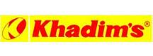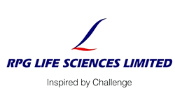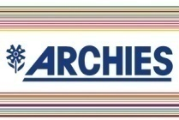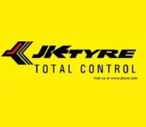

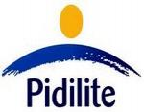Berger paints JCT Sukam Lupin Pharma Relaxo SBL Parijat

